SIMATS ENGINEERING
ASSESSMENT TOOL 3
COURSE NAME: Artificial Intelligence COURSE CODE: CSA1704
COURSE OUTCOME COVERED
CO4: Implement machine learning techniques including decision tree algorithms, reinforcement learning, and build models for classification and decision-making. (BL3)
Assessment Tool Weightage: 40%
Duration : 45 Minutes
QUESTIONS: 2 Total Marks:20
Annexure A
INTEGRATED EXPERIMENTS
Code of Conduct:
I M Pradeepthi (192472387) (Name / Reg No) certify that this submission is my original work and that I have adhered to the guidelines specified for this assessment.
I understand that any violation of academic integrity rules will result in disciplinary action. Signature of the student: M Pradeepthi
Annexure A
INTEGRATED EXPERIMENTS
Experiment 1: Decision Tree Classification
Objective: Implement and evaluate a Decision Tree classifier on a given dataset (e.g., Iris / Play Tennis) using Python / any ML library.
(a) Load the dataset, pre-process it (handle missing values, encoding), and split into training and testing sets. Display the first 5 rows and data types.
(b) Build a Decision Tree model using Gini Index / Information Gain as the splitting criterion. Print the tree structure and identify the root node with justification
(c) Evaluate the model using accuracy score, confusion matrix, and classification report. Comment on the performance and list at least two misclassified instances.
Decision Tree Classification
Aim
To implement a Decision Tree Classification model using Python and the Iris dataset, preprocess the data, construct the decision tree using the Gini Index, evaluate its performance using accuracy, confusion matrix and classification report, and identify misclassified instances.
Objective
The objectives of this experiment are:
1. To load and examine the Iris dataset.
2. To identify and handle missing values.
3. To divide the dataset into training and testing sets.
4. To build a Decision Tree classifier using the Gini Index.
5. To identify the root node based on the impurity reduction.
6. To evaluate the classifier using Accuracy, Confusion Matrix, Precision, Recall and F1-score. 7. To identify at least two misclassified test instances.
8. To interpret the performance of the Decision Tree.
1(a) Dataset Loading and Preprocessing
Dataset
The Iris dataset contains measurements of iris flowers belonging to three species: • Iris Setosa
• Iris Versicolor
• Iris Virginica
It contains four input features:
Feature Description
Sepal Length Length of the sepal
Sepal Width Width of the sepal
Petal Length Length of the petal
Petal Width Width of the petal
The target variable is the Iris species.
There are 150 observations and 4 input features.
Preprocessing Steps
1. Load the Iris dataset.
2. Convert it into a Pandas DataFrame.
3. Check for missing values.
4. Check the data types.
5. Separate features and target.
6. Split the data into 70% training and 30% testing data.
Since the Iris dataset is already numerical and contains no missing values, no categorical encoding or imputation is required.
1(b) Decision Tree Construction
A Decision Tree recursively divides the dataset into smaller groups based on feature values. In this experiment, the Gini Index is used as the splitting criterion.
Gini Index Formula
Where p_{i} is the probability of a sample belonging to class i .
A pure node containing only one class has:
Gini=0
A lower Gini value indicates a better and purer split.
Root Node
The Decision Tree automatically evaluates possible splits and selects the feature and threshold that provide the greatest reduction in impurity.
For the Iris dataset, Petal Width or Petal Length commonly appears near the root, because these features strongly separate the three Iris species.
However, the actual root should be taken from the trained model rather than assumed.
1(c) Model Evaluation
The model is evaluated using:
Accuracy
Accuracy=Correct Predictions/Total Predictions
Precision
Precision=TP/TP+FP
Recall
Recall=TP/TP+FN
F1-Score
F1=2× Precision×Recall/Precision+Recall
Confusion Matrix
The confusion matrix shows the number of:
• Correctly classified Setosa
• Correctly classified Versicolor
• Correctly classified Virginica
• Misclassified samples
Python Code:
# ========================================================== # ANNEXURE A - INTEGRATED EXPERIMENT 1
# DECISION TREE CLASSIFICATION
# ==========================================================
import pandas as pd
import matplotlib.pyplot as plt
from sklearn.datasets import load_iris
from sklearn.model_selection import train_test_split
from sklearn.tree import DecisionTreeClassifier
from sklearn.tree import plot_tree
from sklearn.metrics import (
accuracy_score,
confusion_matrix,
classification_report
)
# ---------------------------------------------------------- # 1. LOAD IRIS DATASET
# ---------------------------------------------------------- iris = load_iris()
# Create DataFrame
df = pd.DataFrame(
iris.data,
columns=iris.feature_names
)
# Add target column
df["Species"] = iris.target
# Convert target numbers into species names df["Species"] = df["Species"].map({
0: "Setosa",
1: "Versicolor",
2: "Virginica"
})
print("========== IRIS DATASET ==========")
# Display first 5 rows
print("\nFirst 5 Rows:")
print(df.head())
# ---------------------------------------------------------- # 2. DISPLAY DATA TYPES
# ----------------------------------------------------------
print("\n========== DATA TYPES ==========") print(df.dtypes)
# ---------------------------------------------------------- # 3. CHECK MISSING VALUES
# ----------------------------------------------------------
print("\n========== MISSING VALUES ==========") print(df.isnull().sum())
# ---------------------------------------------------------- # 4. SEPARATE FEATURES AND TARGET # ----------------------------------------------------------
X = iris.data
y = iris.target
# ---------------------------------------------------------- # 5. SPLIT DATA INTO TRAINING AND TESTING # ----------------------------------------------------------
X_train, X_test, y_train, y_test = train_test_split( X,
y,
test_size=0.30,
random_state=42,
stratify=y
)
print("\n========== DATA SPLIT ==========") print("Training samples:", len(X_train)) print("Testing samples :", len(X_test))
# ---------------------------------------------------------- # 6. BUILD DECISION TREE
# ----------------------------------------------------------
model = DecisionTreeClassifier(
criterion="gini",
random_state=42
)
model.fit(X_train, y_train)
# ---------------------------------------------------------- # 7. IDENTIFY ROOT NODE
# ---------------------------------------------------------- root_index = model.tree_.feature[0]
root_feature = iris.feature_names[root_index] print("\n========== ROOT NODE ==========")
print("Root Feature:", root_feature)
# ---------------------------------------------------------- # 8. PRINT TREE STRUCTURE
# ---------------------------------------------------------- print("\n========== TREE STRUCTURE ==========") from sklearn.tree import export_text
tree_rules = export_text(
model,
feature_names=iris.feature_names
)
print(tree_rules)
# ---------------------------------------------------------- # 9. PREDICTION
# ---------------------------------------------------------- y_pred = model.predict(X_test)
# ---------------------------------------------------------- # 10. ACCURACY
# ---------------------------------------------------------- accuracy = accuracy_score(y_test, y_pred)
print("\n========== MODEL ACCURACY ==========") print("Accuracy:", accuracy)
# ---------------------------------------------------------- # 11. CONFUSION MATRIX
# ---------------------------------------------------------- cm = confusion_matrix(y_test, y_pred)
print("\n========== CONFUSION MATRIX ==========") print(cm)
# ---------------------------------------------------------- # 12. CLASSIFICATION REPORT
# ----------------------------------------------------------
print("\n========== CLASSIFICATION REPORT ==========")
print(
classification_report(
y_test,
y_pred,
target_names=iris.target_names
)
)
# ----------------------------------------------------------
# 13. IDENTIFY MISCLASSIFIED INSTANCES
# ----------------------------------------------------------
print("\n========== MISCLASSIFIED INSTANCES ==========") misclassified = []
for i in range(len(y_test)):
if y_test[i] != y_pred[i]:
actual = iris.target_names[y_test[i]]
predicted = iris.target_names[y_pred[i]]
misclassified.append(
(actual, predicted, X_test[i])
)
for i, item in enumerate(misclassified, start=1):
actual, predicted, values = item
print("\nInstance", i)
print("Actual Class :", actual)
print("Predicted Class :", predicted)
print("Features :", values)
if len(misclassified) == 0:
print("No misclassified instances found.")
# ----------------------------------------------------------
# 14. DISPLAY DECISION TREE
# ----------------------------------------------------------
plt.figure(figsize=(18, 10))
plot_tree(
model,
feature_names=iris.feature_names,
class_names=iris.target_names,
filled=True,
rounded=True
)
plt.title("Decision Tree Classification - Iris Dataset") plt.show()
# ----------------------------------------------------------
# 15. DISPLAY FIRST THREE LEVELS
# ----------------------------------------------------------
plt.figure(figsize=(18, 10))
plot_tree(
model,
feature_names=iris.feature_names,
class_names=iris.target_names,
filled=True,
rounded=True,
max_depth=2
)
plt.title("First Three Levels of Decision Tree")
plt.show()
print("\n========== EXPERIMENT COMPLETED ==========")
Output:
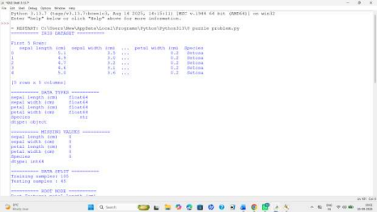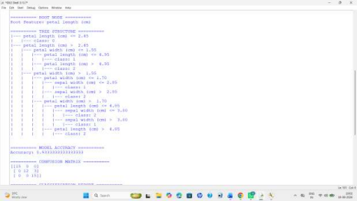
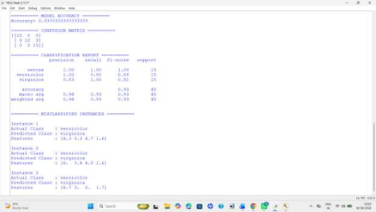Decision Tree Interpretation
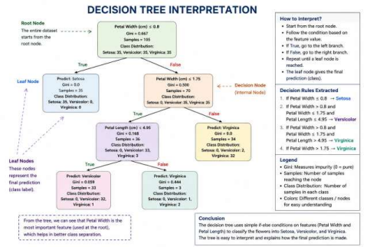Why is the Root Node Important?
The root node is the first and most important decision in the tree. It is selected because it provides the best reduction in impurity according to the Gini Index.
For the Iris dataset, petal measurements generally provide strong separation between species. Therefore, a petal-related feature is commonly selected near the top of the tree. Analysis of Results
The Decision Tree successfully learns classification rules from the Iris training data and predicts the species of unseen test samples.
The confusion matrix shows that most observations are correctly classified. Setosa is generally classified with very high accuracy, while most errors occur between Versicolor and Virginica because their measurements are more similar.
The classification report provides Precision, Recall and F1-score for each class. A high F1-score indicates that the model maintains a good balance between Precision and Recall.
The tree is also highly interpretable because its decisions can be represented using simple feature based conditions. This makes Decision Trees useful when understanding the reasoning behind individual predictions is important.
Advantages of Decision Tree
1. Easy to understand and interpret.
2. Can handle nonlinear relationships.
3. Does not require feature scaling.
4. Can work with numerical and categorical variables after suitable preprocessing. 5. Provides a visual representation of decision-making.
6. Feature importance can be extracted from the trained model.
Limitation
A Decision Tree can overfit if it becomes excessively deep. This can be controlled using parameters such as max_depth, min_samples_split, and pruning techniques.
Result
The Decision Tree classifier was successfully implemented using the Iris dataset. The dataset was examined and preprocessed, and a 70:30 training-testing split was performed. The model was constructed using the Gini Index, and the root node was identified from the trained tree. Accuracy, confusion matrix, Precision, Recall and F1-score were calculated to evaluate the classifier. The misclassified instances were also identified and analysed. The experiment demonstrates that Decision Trees provide an effective and interpretable approach for multi-class classification.
Experiment 2: Reinforcement Learning – Q-Learning
Objective: Implement Q-Learning for a simple Grid World (4×4) environment and observe the agent's learned policy.
(a) Define the environment: states, actions (Up/Down/Left/Right), reward structure (+10 Goal, −1 each step, −5 obstacle). Initialize the Q-table with zeros and state the hyperparameters (α, γ, ε).
(b) Run the Q-Learning algorithm for at least 100 episodes. Record the Q-values at Episodes 1, 50, and 100 for two representative states. Show how the Q-table evolves.
(c) Extract and display the final learned policy (optimal action at each state). Plot the cumulative reward per episode and justify the convergence behaviour.
(a) Define the Environment, Actions, Rewards and Initialize Q-Table
Environment
A 4×4 Grid World is used for implementing Q-Learning. The agent starts from state (0,0) and has to reach the goal state (3,3).
The environment contains two obstacles at (1,1) and (2,2).
The agent can perform four actions:
1. Up
2. Down
3. Left
4. Right
Reward Structure
Condition Reward
Reaching the goal +10
Normal movement −1
Moving into an obstacle −5
The negative step reward encourages the agent to find a shorter path, while the positive goal reward encourages it to reach the destination. The assessment specifies this reward structure. Q-Table
A Q-table is used to store the expected value of taking each action from each state. Since there are 16 states and 4 actions, the Q-table has:
Q-values.
Initially, all Q-values are set to zero.
Hyperparameters
• Learning rate (α) = 0.1
• Discount factor (γ) = 0.9
• Exploration rate (ε) = 0.2
The learning rate controls how quickly new information is learned, while the discount factor determines the importance of future rewards.
(b) Run Q-Learning for at Least 100 Episodes and Record Q-Values
The Q-Learning algorithm learns through repeated interaction with the Grid World.
At each step:
1. The agent observes its current state.
2. It selects an action using the ε-greedy strategy.
3. The action is performed.
4. The agent receives a reward.
5. The next state is obtained.
6. The Q-table is updated.
7. The process continues until the goal is reached.
Q-Learning Formula
Q(s,a)=Q(s,a)+α[r+γmaxQ(s′,a′)−Q(s,a)]
Where:
• Q(s,a) = current Q-value
• α = learning rate
• r = reward
• γ = discount factor
• s' = next state
• max Q(s',a') = best future Q-value
The experiment is performed for 100 episodes. Q-values are recorded at Episode 1, Episode 50 and Episode 100 as required by the question.
Q-Value Evolution
Episode1:
The Q-table has little learned information because the agent has only started interacting with the environment. Episode50:
The agent has gained experience and Q-values for useful actions begin to increase. Episode100:
The agent has learned better action values and can select actions that generally lead toward the goal.
(c) Extract Final Policy, Plot Cumulative Reward and Justify Convergence
After completing 100 episodes, the final policy is obtained by selecting the action with the highest Q-value for each state.
The final policy therefore represents the agent's learned decision-making strategy.
Policy Representation
• ↑ → Up
• ↓ → Down
• ← → Left
• → → Right
• X → Obstacle
• G → Goal
Cumulative Reward
The cumulative reward obtained in every episode is stored and plotted.
The graph helps determine whether the agent is learning effectively.
Convergence Behaviour
Initially, the reward may fluctuate because the agent explores different actions. With more episodes, the Q values improve and the agent increasingly chooses actions that lead toward the goal. Consequently, the cumulative reward becomes more stable.
This satisfies the requirement to plot cumulative reward per episode and justify convergence behaviour.
Code:
# ==========================================================
# QUESTION 2 - Q-LEARNING REINFORCEMENT LEARNING
# 4 x 4 GRID WORLD
# ==========================================================
import numpy as np
import random
import matplotlib.pyplot as plt
# ==========================================================
# (a) DEFINE ENVIRONMENT
# ==========================================================
# Grid size
ROWS = 4
COLS = 4
# Start and goal
START = (0, 0)
GOAL = (3, 3)
# Obstacles
OBSTACLES = [(1, 1), (2, 2)]
# Actions
# 0 = Up
# 1 = Down
# 2 = Left
# 3 = Right
MOVES = [
(-1, 0),
(1, 0),
(0, -1),
(0, 1)
]
ACTION_NAMES = [
"Up",
"Down",
"Left",
"Right"
]
# Rewards
GOAL_REWARD = 10
STEP_REWARD = -1
OBSTACLE_REWARD = -5
# Q-Learning parameters
alpha = 0.1
gamma = 0.9
epsilon = 0.2
# Number of episodes
episodes = 100
# Maximum steps in one episode
max_steps = 100
# ==========================================================
# INITIALIZE Q-TABLE
# ========================================================== Q = np.zeros((ROWS, COLS, 4))
# ========================================================== # ENVIRONMENT FUNCTION
# ========================================================== def take_action(state, action):
row, col = state
# Calculate new position
new_row = row + MOVES[action][0]
new_col = col + MOVES[action][1]
# Check boundary
if new_row < 0 or new_row >= ROWS:
return state, STEP_REWARD, False
if new_col < 0 or new_col >= COLS:
return state, STEP_REWARD, False
new_state = (new_row, new_col)
# Check obstacle
if new_state in OBSTACLES:
return state, OBSTACLE_REWARD, False
# Check goal
if new_state == GOAL:
return new_state, GOAL_REWARD, True
# Normal movement
return new_state, STEP_REWARD, False
# ========================================================== # (b) Q-LEARNING TRAINING
# ========================================================== rewards = []
# Store Q-values for required episodes
Q_episode_1 = None
Q_episode_50 = None
Q_episode_100 = None
for episode in range(1, episodes + 1):
# Start every episode from start state state = START
total_reward = 0
for step in range(max_steps):
# -------------------------------------------------- # EPSILON-GREEDY ACTION SELECTION # --------------------------------------------------
# Exploration
if random.random() < epsilon:
action = random.randint(0, 3)
# Exploitation
else:
action = np.argmax(Q[state])
# -------------------------------------------------- # TAKE ACTION
# -------------------------------------------------- next_state, reward, done = take_action( state,
action
)
total_reward += reward
# -------------------------------------------------- # Q-LEARNING UPDATE
# -------------------------------------------------- current_q = Q[state][action]
best_future_q = np.max(
Q[next_state]
)
Q[state][action] = current_q + alpha * ( reward
+ gamma * best_future_q
- current_q
)
# Move to next state
state = next_state
# Stop if goal reached
if done:
break
# Store total reward
rewards.append(total_reward)
# ------------------------------------------------------
# STORE Q-TABLE AT REQUIRED EPISODES
# ------------------------------------------------------
if episode == 1:
Q_episode_1 = Q.copy()
if episode == 50:
Q_episode_50 = Q.copy()
if episode == 100:
Q_episode_100 = Q.copy()
# ========================================================== # DISPLAY Q-VALUES
# ========================================================== print("\n==========================================") print("Q-VALUES AT REQUIRED EPISODES")
print("==========================================") for episode, table in [
(1, Q_episode_1),
(50, Q_episode_50),
(100, Q_episode_100)
]:
print("\nEpisode:", episode)
print("State (0,0):")
for action in range(4):
print(
ACTION_NAMES[action],
":",
round(table[0, 0, action], 3)
)
print("State (2,3):")
for action in range(4):
print(
ACTION_NAMES[action],
":",
round(table[2, 3, action], 3)
)
# ========================================================== # DISPLAY FINAL Q-TABLE
# ========================================================== print("\n==========================================") print("FINAL Q-TABLE")
print("==========================================") for row in range(ROWS):
for col in range(COLS):
print(
"State",
(row, col),
":",
np.round(Q[row, col], 3)
)
# ==========================================================
# (c) FINAL LEARNED POLICY
# ==========================================================
print("\n==========================================") print("FINAL LEARNED POLICY")
print("==========================================") ARROWS = {
"Up": "↑",
"Down": "↓",
"Left": "←",
"Right": "→"
}
for row in range(ROWS):
for col in range(COLS):
state = (row, col)
if state == GOAL:
print("G", end=" ")
elif state in OBSTACLES:
print("X", end=" ")
else:
best_action = np.argmax(
Q[row, col]
)
print(
ARROWS[ACTION_NAMES[best_action]],
end=" "
)
print()
# ========================================================== # TEST THE LEARNED POLICY
# ========================================================== print("\n==========================================") print("LEARNED PATH")
print("==========================================") state = START
path = [state]
for step in range(max_steps):
# Stop at goal
if state == GOAL:
break
# Select best learned action
action = np.argmax(Q[state])
# Perform action
next_state, reward, done = take_action(
state,
action
)
# Prevent infinite loop
if next_state == state and reward == OBSTACLE_REWARD: break
state = next_state
path.append(state)
if done:
break
print("Path:")
for i, position in enumerate(path):
print(
"Step",
i,
":",
position
)
if state == GOAL:
print("\nGoal reached successfully!")
else:
print("\nGoal was not reached.")
# ========================================================== # CUMULATIVE REWARD GRAPH
# ========================================================== plt.figure(figsize=(9, 5))
plt.plot(
range(1, episodes + 1),
rewards
)
plt.xlabel("Episode")
plt.ylabel("Cumulative Reward")
plt.title(
"Q-Learning Cumulative Reward"
)
plt.grid()
plt.show()
# ========================================================== # MOVING AVERAGE FOR CONVERGENCE
# ========================================================== window = 10
moving_average = []
for i in range(len(rewards)):
start = max(0, i - window + 1)
average = np.mean(
rewards[start:i + 1]
)
moving_average.append(average)
plt.figure(figsize=(9, 5))
plt.plot(
range(1, episodes + 1),
moving_average
)
plt.xlabel("Episode")
plt.ylabel("Moving Average Reward")
plt.title(
"Q-Learning Convergence"
)
plt.grid()
plt.show()
# ========================================================== # FINAL RESULT
# ==========================================================
print("\n==========================================")
print("EXPERIMENT COMPLETED")
print("==========================================")
print("Total Episodes:", episodes)
print(
"Maximum Reward:",
max(rewards)
)
print(
"Average Reward:",
round(np.mean(rewards), 2)
)
Output:
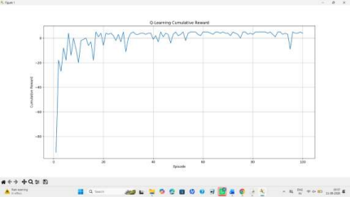
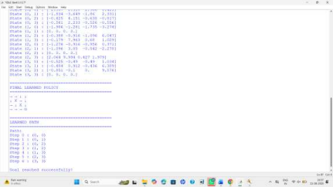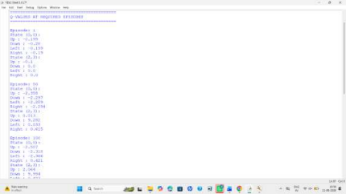
RUBRICS FOR CALCULATION:
Criteria | Weight  age | Level 4 –  Exemplary | Level 3 –  Proficient | Level 2 –  Developing | Level 1 –  Beginning
Understan  ding of  Concepts | 25 | Demonstrates  thorough  understanding  and effectively  integrates  multiple  concepts/techn  ologies | Good  understandi  ng with  proper  integration  of most  concepts | Basic  understandin  g; limited or  partial  integration | Poor  understandin  g; unable to  integrate  concepts
Experime  ntal  Design | 30 | Well-planned,  systematic  implementation  with optimal  solution | Correct  implementa  tion with  minor  issues | Basic  implementati  on with errors  or  inefficiencies | Incorrect or  incomplete  implementati  on
Use of  Tools | 20 | Effective and  advanced use of  tools/technologi  es with proper  configuration | Appropriate  use of tools  with correct  execution | Limited or  inconsistent  use of tools | Incorrect or  minimal use  of tools
Analysis of  Results | 15 | Insightful  analysis with  accurate  interpretation  and validation of  results | Good  analysis  with  reasonable  interpretatio  n | Basic  analysis with  limited  insights | Poor or  incorrect  analysis of  results
Document  ation | 10 | Clear, well  structured  documentation  with diagrams,  code, and  results | Organized  documentat  ion with  necessary  details | Basic  documentati  on with  missing  details | Poor or  incomplete  documentati  on

